[Working title]: Foliar fungal symbionts in sympatric yellow monkeyflowers along elevation gradients in the Sierra Nevada

Bolívar Aponte Rolón1,✉, Kathleen G. Ferris2, and Sunshine A. Van Bael2

February 26, 2024

1 Tulane University  
2 Department of Ecology and Evolutionary Biology, Tulane University, 6823 St. Charles Avenue, New Orleans, LA 70118

✉ Correspondence: [Bolívar Aponte Rolón <baponterolon@tulane.edu>](mailto:baponterolo@tulane.edu)

## 0.1 Keywords

# 1. Abstract

# 2. Introduction

Phenotypic plasticity and genetic adaptation are key drivers of evolution, and both processes may aid in plant adaptation to a warming climate (Jump & Peñuelas, 2005). Plant’s colonization of land across multiples climates has been aided by their parallel evolution with fungi and bacteria; however, little is known about how plant microbiomes influence or are influenced by local adaptation or phenotypic plasticity of plants. Lack of knowledge about this is a problem because ecology aims to predict how plant distribution may change as the climate becomes further altered. Previous studies have suggested that foliar endophytic fungi (FEF) can alter plant traits under stressful conditions such as drought (Song et al., 2016). FEF live in plant leaves and they may contribute to local adaptation and/or phenotypic plasticity. Host genetics may shape the foliar microbiomes of plants. For example, a study on the classical plant model, *Arabidopsis thaliana*, revealed that bacterial and fungal communities in leaves are shaped by host genotype, at least for the most common OTUs (Horton et al., 2014). Another ideal model system to explore the interactions between leaf traits and FEF are the yellow monkeyflowers in the *Mimulus guttatus* species complex. Over the last 2 decades, the *M. guttatus* species complex has become a model system for answering questions about local adaptation and phenotypic plasticity (Wu et al., 2008; Yuan, 2019). Experimental manipulation is relatively easy due to its small genome (about 430 Mb), short generation time, high fecundity, self-compatibility, and ease of greenhouse propagation (Society, 2019; Wu et al., 2008) Currently, studies of the *M. guttatus* species complex focus on the genetic and environmental factors driving local adaptation and phenotypic plasticity. The evolution of leaf shape for 3 edaphic species in the *M. guttatus* complex is controlled by overlapping genetic regions (Ferris et al., 2015). Ferris et al., (2015) points to multiple events of leaf shape evolution in the *M. guttatus* species complex and their associated habitats. Recent work has narrowed the genetic architecture at play in incomplete reproductively isolated sympatric populations of *Mimulus laciniatus* and *Mimulus guttatus*, shedding light on the location of quantitative trait loci (QTL) for the first flower node, flowering time, corolla width, corolla length, and leaf shape and suggesting that large-effect loci underlie these traits (Ferris et al., 2017). There is scarce research that focuses on the symbionts of *Mimulus* spp. Beslile et al. (2012) reported on the distribution of diverse fungal communities in the flower nectar of *Mimulus aurantiacus*. The authors considered flowers as islands in a metapopulation system and found that the frequency of micro fungi (i.e., yeasts) was significantly correlated to the location of the plant and marginally correlated with the density of the flowers in the plant (Beslile et al., 2012). To our knowledge, no previous studies have considered symbionts in leaf tissue of *Mimulus* spp. and how leaf functional traits influence symbiont community composition. Given the potential benefits FEF can provide their hosts under stressful conditions (CITE) and the wide range of habitats the *M. guttatus* species complex occupies, it is important to understand the role of FEF communities play in *Mimulus* spp. The aim of this study was to explore some baseline questions about the FEF communities in sympatric populations of *Mimulus* spp.along an elevation gradient. We formulated the following questions: 1) Are there differences in leaf functional traits and FEF communities *among* sympatric *Mimulus* spp. populations? 2) Do leaf functional traits and FEF communities differ *within* species along an elevational gradient? 3) Does an interaction exist between elevation and species regarding leaf functional traits and FEF communities? We expect the diversity, richness, and abundance of FEF communities will be similar within the same sites (alpha diversity) than among sites (beta diversity) regardless of host species.

# 3. Materials and Methods

## 3.1 Sample Collection

We collected plant specimens populations of *M. guttatus*, *M. laciniatus*, and *M. nasutus* (syn. *Erythranthe guttata* , *Erythranthe laciniata*, and *Erythranthe nasuta*) across Stanislaus National Forest (SNF), Sierra National Forest (SINF) and Yosemite National Park (YNP), CA, USA. during We haphazardly selected sites close to the main roads based on the presence of a viable population of at least ~ 50 individuals per species. Samples collected from YNP were collected from non-wilderness areas on the side of the road. We determined population viability ensuring that they had individuals flowering or close to flowering stage. We collected between 6 - 12 individuals per species per site. We selected individuals that possessed healthy looking leaves, no visible signs of pathogen damage or senescence. At sites were two species were present we collected individuals that were at least ~ 25 meters apart. We collected sample specimens by carefully uprooting the plant and placing into individual plastic bags (e.g., Ziploc®) and preserving in an ice chest until return to the field laboratory at the UC Merced Yosemite Field Station, YNP, CA, USA. Plant specimens were processed within 8 hrs of collection.

## 3.2 Leaf traits measurement

From each plant, we measured leaf traits: leaf thickness (LT), leaf punch strength (LPS), leaf mass per area (LMA), anthocyanin content index (ACI) which are known to be associated with FEF communities (Tellez et al., 2022) as well as leaf lobe index (LBI) (Ferris et al., 2015). We cleaned plants with tap water to remove all soil and debris remnants from the leaves and roots. We removed all healthy leaves (~ 5 - 10) from the stems and took three measurements per trait from three haphazardly selected leaves from individual plants, with the exception of LBI, only one leaf per plant. We used a transparency film to hold the leaf in place and flatten, after which we took a digital photograph for further analysis. To calculate the LBI, we followed (2015). Brieflly, leaf lobing is calculated as the convex hull area minus the true leaf area divided by convex hull area of a digital photograph of a leaf in ImageJ [v1.52r; Schneider et al. (2012)]. We measured ACI content with ACM-200plus (Opti-Sciences Inc. Hudson, New Hampshire, U.S.A.) on haphazardly selected locations of the leaf surface (working from the petiole out to the leaf tip) (Tellez et al., 2022). The ACM-200 calculates an ACI value from the ratio of % transmittance at 931 nm/% transmittance at 525 nm (Inc., n.d.), effectively accounting for leaf thickness. We measured LT (μm) with a Mitutoyo 7327 Micrometer Gauge (Mitutoyo, Takatsu-ku, Kawasaki, Japan) on haphazardly selected locations of the leaf lamina, taking care to avoid major and secondary veins. We used an Imada DST-11a digital force gauge (Imada Inc., Northbrook, IL, United States) to measure LPS, a measure of leaf toughness, on the lamina of each leaf selected, avoiding minor leaf veins when possible (Tellez et al., 2022). It functions by conducting punch-and-die tests with a sharp-edged cylindrical steel punch (2.0 mm diameter) and a steel die with a sharp-edged aperture of small clearance (0.05 mm). Once LPS was measured, we used a 4 mm diameter punch hole to puncture disks for LMA measurements. We collected one disk per leaf (see Supplementary material for details). The disk punches dried were shipped to Tulane University, New Orleans, LA, USA to dry at 60 ℃ for 48-72 hours before being weighed.

## 3.3 Molecular Work

### 3.3.1 Tissue preservation

Upon completion of the leaf traits measurements, we prepared and preserved samples at the UC Merced Yosemite Field Station. We started by removing the main vein and margins from photosynthetic tissue. The leaf lamina was haphazardly cut with a sterile blade into 2 mm wide strip in parallel to the main vein (Arnold et al., 2003; Higgins et al., 2014; Tellez et al., 2022). Leaf strips were then sterilized with sequential washes in 95% EtOH (10 s), 0.5% sodium hypochlorite (NaOCl) (60 s), and 70% EtOH (60 s) and air dried under sterile conditions. Due to the small size of monkeyflower plants, the maximum amount of leaf lamina was preserved in sterile 15 mL tubes with ~ 10 mL CTAB solution (1 M Tris–HCl pH 8, 5 M NaCl, 0.5 M EDTA, and 20 g CTAB). The leaf tissue in CTAB solution was used for amplicon sequencing (described in detail below). All leaf tissue handling was performed in a sterile environment with an alcohol burner lamp inside a portable biosafety cabinet. All surfaces were previously sterilized sequentially with 0.5% NaOCl, 95% EtOH, and 70% EtOH. We surface sterilized surfaces and instruments in between sample handling to prevent cross contamination.

### 3.3.2 Amplicon sequencing

We stored leaf tissue in CTAB solution for 2 months at room temperature before extracting DNA at Tulane University. To prepare for sample DNA extraction procedure, we decontaminated all instruments, materials, and surfaces in biosafety cabinet with 0.5 % NaOCl, 70 % EtOH, and 95% EtOH, and subsequently treated with UV light for 30 minutes. We subsampled 0.2 - 0.3 g of leaf tissue from each sample and placed into a sterile 2 mL tubes containing an assortment of beads: 3.2 mm stainless steel beads (Next Advance, Cat# SSB32), 100 µL stainless steel bead blend, 0.9-2.0mm (NextAdvance, Cat# SSB14B) and 2-3 of the autoclaved 2 mm zirconium oxide beads (Next Advance, Cat# ZRoB20). The 2 mL tubes with beads were previously prepared. We then proceeded to lyophilize samples for 72 hours to fully remove CTAB content from tissue. After, we submerged the sample tubes in liquid nitrogen for 30 s and homogenized samples at 30 Hz for 3 minutes in a TissueLyser LT (QIAGEN, Valencia, CA, USA). We stored samples in 20 ℃ until DNA extraction procedure.

We used a DNA extraction protocol for high-molecular weight DNA extraction adapted from Russo et al., (2022). Briefly, it is a CTAB:chloroform:isoamyl extraction combined with a solid-phase reversible immobilization (SPRI) bead step (Liu et al., 2023; Rohland & Reich, 2012; Russo et al., 2022). Protocol modifications allowed us to optimize extractions for fungal DNA from preserved leaf tissue (see details in Aponte Rolón, 2023). After all genomic DNA was extracted, we quantified the DNA using Quant-iT® dsDNA HS Assay kit with Qubit Flourometer (Thermo Fisher Scientific, Waltham, MA, USA., Cat# Q33120) and followed a two-step amplification approach described by (2017) and (2017). We used standard primers ITS1F (Gardes & Bruns, 1993) and ITS2 (White et al., 1990) modified with the Illumina TruSeq adaptor. The modified primers for the first PCR (adapter ligation and ITS1 amplification) were as follows: 5’ CACTCTTTCCCTACACGACGCTCTTCCGATCTCTTGGTCATTTAGAGGAAGTAA 3’ (forward) and 5’ GTGACTGGAGTTCAGACGTGTGCTCTTCCGATCTGCTGCGTTCTTCATCGATGC 3’ (reverse). Every sample was amplified in three parallel reactions at the annealing temperatures 52 ℃, 54 ℃, and 56 ℃ to amplify a wide range of fungal taxa and reduce amplification bias for short ITS sequences (Lumibao et al., 2018; U’Ren & Arnold, 2017). Each PCR (PCR1) reaction contained 2 µL of sample DNA template. We visualized PCR1 reactions with SYBR™ Safe DNA Gel Stain (Thermo Fisher Scientific, Waltham, MA, USA., Cat# S33102) on 2% agarose gel (Oita et al., 2021). We combined 5 µL of amplicon product from parallel reactions in to a single tube per sample and purified using Sera-Mag™ SpeedBead Carboxylate-Modified Magnetic Particles (Hydrophobic) (Thermo Fisher Scientific, Waltham, MA, USA., Cat#09-981-123) prepared as per Liu et al. (2023) and used a ratio of 1.2x:1 with 80% EtOH following manufacturers instructions. We used 3 µL of PCR1 product from samples, DNA extraction controls, and PCR1 negative controls for a second PCR (PCR2) with barcoded adapters (IDT, Coralville, Iowa, USA). Each PCR2 reaction (total 30 µL) contained 1X Phusion Flash High Fidelity PCR Master Mix (Thermo Fisher Scientific, Waltham, MA, USA., Cat# F548L), 0.075 µM of barcoded primers (forward and reverse pooled at an initial concentration of 2 µM) and 0.20mg/mL of BSA (Thermo Fisher Scientific, Waltham, MA, USA., Cat# B14) following U’Ren & Arnold (2017). Before final pooling for sequencing, we purified and concentrated amplicons using SPRI beads to a total volume of 20 µL. We quantified PCR2 product with Quant-iT™ PicoGreen™ dsDNA Assay Kit (Thermo Fisher Scientific, Waltham, MA, USA., Cat# P7589) with the BioTek Synergy LX plate reader (Agilent, Santa Clara, CA) and combined equimolar amounts of libraries, including DNA extraction controls, PCR1, and PCR2 negative controls into a 10nM library pool. We did not detect any contamination visually or fluorometrically. Libraries were sequenced on the Illumina MiSeq platform with Reagent Kit v3 (2 0D7 300 bp) at Duke Genome Sequencing and Analysis Core Facility (Durham, NC, USA). Throughout all these steps, we used a separate set of sterile pipettes, tips, and equipment to reduce contamination in a designated PCR area to restrict contact with pre-PCR materials (Oita et al., 2021).

### 3.3.3 Bioinformatic analyses

We assessed the quality of the reads using FastQc v0.12.1 [ v0.12.1; Andrews et al. (2010)] and MultiQC (Ewels et al., 2016) tools. A total of 60,696,808 total ITS1 reads yielded from 343 (including 27 controls) libraries sequenced in two separate sequencing runs. The first sequencing event yielded 32,117,684 and the second 28,579,124 ITS1 reads. We tailored the open-source DADA2 (Callahan et al., 2016) bioinformatic pipeline for our data set. We filtered our reads for ambiguous calls before removing the adapters by using filterAndTrim function and argument maxN = 0 from the dada2 package [v1.28.0; Callahan et al. (2016)]. We removed forward and reverse primer adapters (and their reverse compliments) and eliminated reads shorter than 20 bp using the cutadapt tool (v4.6, Martin, 2011). Based on our initial quality assessment, both forward and reverse reads were of low quality, with base calls deteriorating after 100 bp. We applied stringent filter and truncation parameters to ensure quality of reads when assigning taxonomy. We filtered and truncated reads based on maximum expected errors (maxEE) rather than read length as it provides a reliable quality filtering (Edgar & Flyvbjerg, 2015). For this we set set the arguments trunQ = 2, maxEE = c(2,20) for forward and reverse reads, and minimum read length of 50 bp with minLen = 50 in the used the filterAndTrim function (Callahan et al., 2016). These parameters eliminated 151 samples from our data set, all from our second sequencing event. After this filter, we dereplicated reads with the derepFastq function and merged pairs using mergePairs functions with an overlap of 20 bp, minimum. We then inferred composition of the samples with dada function, which applies the DADA algorithm (Callahan et al., 2016; Rosen et al., 2012). We removed chimeras via the “consensus”method with the removeBimeraDenovo function and ultimately we used the assignTaxonomy function to assign taxonomy the amplicon sequence variants (ASV) referenced against the UNITE database (Abarenkov et al., 2023). After taxonomy assignment we used the phyloseq package (McMurdie & Holmes, 2013) to create a phyloseq object for downstream analyses.

We used the decontam package [v1.20.0; Davis et al. (2018)] to statistically determine which ASVs are likely contaminants based on their frequency in our samples and remove them using prune_taxa function from the phyloseq package [v1.44.0; McMurdie & Holmes (2013)]. After which, we calculated the average read count found in DNA and PCR extraction controls, considered to be laboratory contaminants, and subtracted that from the samples’ read counts. We then used custom scripts to remove any ASV that represented less than 0.1% of the abundance per sample on the assumption that it originates from contamination throughout handling of samples in the DNA and PCR processes. We removed singletons ASVs with the prune_taxa function (McMurdie & Holmes, 2013). All these bioinformatic steps were performed in *R* [v.4.3.2; R Core Team (2023)].

## 3.4 Statistical Analyses

Before performing statistical analyses, we checked for normality and homoscedasticity of the leaf traits measured. We used Shapiro-Wilk and Fligner-Killen tests from the stats package (R Core Team, 2023) to check for normality and homoscedasticity, respectively. We established that the data was not normally distributed and not homoscedastic. We then used non-parametric tests to compare leaf traits among species and sites. We used the Wilcoxon Rank Sum test to compare leaf trait means among species and sites. We used the compare_means and 'stat_compare_meansfunctions from the ggpubr package (Kassambara, 2023) to perform these tests and properly visualize them. We adjusted *p* values to account for false discovery rates in multiple comparisons by using “BH” method (Benjamini & Hochberg, 1995). We performed Principal Component Analysis (PCA) to understand patterns and relationships among leaf traits of host species. We used the prcomp function from the vegan package (Oksanen et al., 2022) compute the PCA analysis with variables ACI, LT, LPS, LMA, and LBI, all log-transformed. We used only complete raw leaf functional traits measurements to compute the PCA analysis (*n* = 504), samples with missing values were omitted.

To facilitate our understanding of the effects of elevation on FEF communities, we categorized elevation as “low” (< 1219 m.a.s.l), “mid” (1220 - 1828 m.a.s.l.) and “high” (> 1829 m.a.s.l.). We then calculated alpha diversity per sample as in different measure of Hill orders, the observed richness (q = 0), the exponent of Shannon diversity index (q = 1), and the inverser Simpson index (q = 2) with phyloseq’s estimated-richness function (McMurdie & Holmes, 2013). We used the vegdist function from the vegan package (Oksanen et al., 2022) to calculate the Bray-Curtis dissimilarity matrix, a measure of beta diversity, to compare the FEF communities within each monkeyflower species across sites and elevation. Additionally, we used a distance-based Redundancy Analysis (dbRDA) to statistically compare the FEF community similarities within each species per site. We modeled the dbRDA analysis with all leaf functional traits included and elevation as a continuous variable. Its visualizations effectively portray underlying patterns of compositional differences (Anderson, 2017; Legendre & Anderson, 1999; McArdle & Anderson, 2001), akin to permutational analysis of variance. We used the anova.cca function to assess the marginal significance of constraining variables (Legendre et al., 2011; Legendre & Legendre, 2012; Oksanen et al., 2022). We corroborated homogeneous dispersion of variances with a permutational analysis of multivariate dispersion (PERMDISP) using the betadisper with parameter type = "centroid", and permutest functions from the vegan package (Oksanen et al., 2022). We used a post-hoc Tukey’s test to compare the differences in the dispersion of the FEF communities among sites and elevation categories. We used the simper function from the vegan package to discriminate which species contribute the most to compositional differences between groups (Oksanen et al., 2022).

Ultimately, we calculated distance matrix of geographical distances between sites using the Vicenty (ellipsoid) method with the geosphere package (Hijmans, 2022). To test the correlation between the geographical distance matrix and FEF community dissimilarity (Bray-Curtis dissimilarity) per host species, we used the mantel function with from the vegan package (Oksanen et al., 2022). We set used the method “spearman” and 999 permutations. All statistical analyses were performed in *R* programming language[v.4.3.2; R Core Team (2023)].

# 4. Results

We obtained 5,082,229 reads representing 726 ASVs from 174 samples after processing samples through the DADA2 pipeline. The raw reads obtained were composed of 26.81% Ascomycota, 71.53% Basidiomycota, <0.05% Chytridiomycota, <0.5% Mortierellomycota, <0.03% Olpidiomycota, 0.01% Rozellomycota, <0.001% Aphelidiomycota, and 1.19% missed BLAST hits. After decontamination, and removal of singletons we obtained 4,971,645 reads representing 231 ASVs from 160 samples composed of 25.88% Ascomycota, 73.1% Basidiomycota, 0.01% Chytridiomycota, <0.1% Mortierellomycota, 0.02% Olpidiomycota, <0.002% Rozellomycota and <1.0% unknown reads. We present the log-transformed leaf functional trait data at the leaf level: ACI (*n* = 854), LT (*n* = 930), LPS (*n* = 878), LMA (*n* = 594), LBI (*n* = 772). The FEF community data is presented at the plant/sample level (*n* = 157).

We found that leaf functional traits differed among and within *Mimulus* species across elevation (Fig. S1 - S5). For LMA, when we observed all species, we saw a statistically siginificant positive correlation between LMA and elevation R2-adjusted= 0.041, *p* <0.001)(Fig. S1B). When we observed this relationship with categorical elevation, we found that species do not differ in LMA values at low elevations (Fig. S1B). At medieum elevations *M. laciniatus* and *M. guttatus* have statistically siginificant differences (*p* <0.001), while at high elevation this difference dissipates. At high elevation we saw that *M. nasutus* differs siginificantly from both *M. laciniatus* and *M. guttatus* (*p* <0.0001)(Fig. S1A). For ACI, when we observed all species, we found no correlation with elevation (R2-adjusted < -0.000, *p* <0.0001)(Fig. S2B). But when we observed the elevation categories we saw that *M. laciniatus* had statistically signdificant differences (*p* < 0.0001) from *M. nasutus* and *M. guttatus*, while the latter two did not differ (Fig. S2A. At mid we saw that *M. laciniatus* and *M. guttatus* had statistically significant differences (*p* <0.0001), while at high elevations *M. laciniatus* had siginificantly lower levels (*p* < 0.0001) of ACI than *M. nasutus*, and *M. guttatus* (*p* <0.01)(Fig. S2A). We also saw statistically significant differences between *m. nasustus* and *M. guttatus* at high elevations (*p* <0.0001)(Fig. S2A). The LBI trait is a measure of leaf “lobeness” and it is confounded with species, regardless our comparisons show that LBI is significantly correlated with elevation (Fig. S3B). Our categorical comparison shows that *M. laciniatus* had statistically significant greater values of LBI compared to *M. nasutus* and *M. guttatus* at all elevation categories (Fig. S3A). At low elevations, *M. nasutus* and *M. guttatus* did not differ, but they did have sigficiant differences at high elevations (p <0.0001)(Fig. S3A). Our measure of leaf toughness, LPS, was significantly positively correlated with elevation R2-adjusted= 0.004, *p* = 0.032)(Fig. S4B). At low elevations we saw a statistically significant difference in LPS between *M. nasutus* and *M. guttatus* (*p* <0.01), while at mid elevations *M. laciniatus* and *M. guttatus* showed a similar pattern (*p* < 0.0001)(Fig. S4A). At high elevations we only saw significant differences between *M. laciniatus* and *M. nasutus* (*p* < 0.01)(Fig. S4A). Finally, we saw a significant positive correlation between LT and elevation (R2-adjusted= 0.013, *p* < 0.0001), when we observe all species together (Fig. S5B). We only see statistically significant differences between *M. laciniatus* and *M. nasustus* at low elevations(*p* <0.05 ), while at mid we see significant differences between *M. laciniatus* and *M. guttatus* (*p* < 0.0001) and at high elevations as well (*p* < 0.0001)(Fig. S5A). At high elevations, *M. guttatus* and *M. nasutus* also show significant differences (*p* < 0.0001)(Fig. S5A).

Our PCA analysis showed how leaf functional traits were related. We plotted leaf functional traits according to species groups on the PCA axes to show how the variance in the complete data set is explained by PC1 (~43%) and PC2 (22.5%) (Fig. 1). The PCA analyses showed ACI, LT, LPS, and LMA loadings tracked along PC1 towards positive values, showing correlation among the traits (Fig. 1). We observed that LBI loading is orthogonal along PC2 to the other traits, indicative of low correlation. We note distinct groupings by species along PC2 such that *M. laciniatus*, the most lobed species, is distinct from *M.gutatus* and *M. nasutus*. The latter two overlap along PC1 and PC2 (Fig. 1).

To determine the correlation between FEF diversity and elevation, we calculated simple linear regressions between elevation and alpha diversity. At the species level, we did not observe a significant change in alpha diversity as elevation increased (Fig. 2A - 2C). Nevertheless, the general point to a decrease in alpha diversity as elevation increases (Fig. 2). When we observed the complete data set we did see a statistically significant negative correlation between elevation and observed richness (𝑞 = 0) (R2-adjusted= 0.05, *F*158= 6.795, *p* = 0.01), the exponent of Shannon diversity index (𝑞 = 1) (R2-adjusted= 0.08, *F*158= 15.06, *p* < 0.001), and the inverse Simpson diversity index (𝑞 = 2) (R2-adjusted= 0.08, *F*158= 14.24, *p* < 0.001). We found statistically significant differences in alpha diversity between *M. laciniatus* and *M. guttatus* (Fig. 3A - 3C), while *M. nasutus* differed significantly from *M. laciniatus* in Hill order 1 (𝑞 = 1) (*p* <0.01) and Hill order 2 (𝑞 = 2) (*p* <0.05). We observed statistically significant differences in beta diversity between low and high elevation sites for Hill order 1 (*p* <0.01) and 2 (*p* < 0.05)(Fig. 3E - 3F). We also observed statistically significant differences in Hill order 0 (𝑞 = 0) between mid in high elevation sites (Fig. 3D). The presence of Ascomycota and Basidiomycota was consistent across all sites and species, with Basidiomycota being the most abundant phylum across all samples (Fig. 4). MAYBE ADD SOME MORE INFO HERE.

To test for differences in FEF community composition, we used a distance-based redundancy analysis (dbRDA) to model the relationship between FEF communities, leaf functional traits and elevation. The analyses revealed that 4.30% of the overall variance inf FEF communities was accounted for by the leaf functional traits and elevation, the constraining variables. We saw that the first axis (dbRDA1) explained 40.8% and the second axis (dbRDA2) explained 27% of the constrained variance (Fig. 5). We observed a distinct, yet overlapping, grouping of FEF communities by species (Fig. 5A), as well as when visualized by elevation category (Fig. 5B). Elevation tracks along dbRDA1 while leaf functional traits track along dbRDA2 (Fig. 5). We found that LBI and elevation are significantly correlated with FEF communities (PERMANOVA TABLE COMMING SOON). To corroborate our findings, we used a permutational analysis of multivariate dispersion (PERMDISP) to test for homogeneity of variances in FEF communities. We found that FEF communities were homogenous across all species (*F*157= 2.66, *p* = 0.07). The post-hoc Tukey’s test revealed that all species comparison were not signifcant. We did find statistically significant differences in the dispersion of FEF communities by elevation category (*F*157= 3.89, *p* = 0.02). The post-host Tukey’s test showed that low and high elevation sites had significantly different dispersion of FEF communities (*p* < 0.05). Finally, we tested for FEF community dissimilarity by geographical distance and found a statistically significant positive correlation when we observed all host species (*r* = 0.06, *p* < 0.01) (Fig. 6A). At the host species level, we saw no siginificant correlation between FEF community and geographical distance for *M. laciniatus* (*r* = 0.03, *p* = 0.26) and *M. guttatus* (*r* = 0.05, *p* = 0.15) (Fig. 6B). For *M. nasutus* we saw an opposite trend, we saw a negative correlation between FEF communities and geographic distance (*r* = 0.20, *p* = 0.001)(Fig. 6B).

# 5. Discussion

# 6. Conclusion

# 7. Author Contributions

# 8. Acknowledgements

# 9. Conflict of Interest Statement

The authors declare no competing interests.

# 10. Data Availability Statement

# 11. References

Abarenkov, K., Zirk, A., Piirmann, T., Pöhönen, R., Ivanov, F., Nilsson, R. H., & Kõljalg, U. (2023). *UNITE general FASTA release for Fungi 2* [Application/gzip]. UNITE Community. <https://doi.org/10.15156/BIO/2938068>

Anderson, M. J. (2017). Permutational Multivariate Analysis of Variance ( PERMANOVA ). In *Wiley StatsRef: Statistics Reference Online* (pp. 1–15). Wiley. <https://doi.org/10.1002/9781118445112.stat07841>

Andrews, S., Krueger, F., Segonds-Pichon, A., Biggins, L., Krueger, C., & Wingett, S. (2010). *FastQC* (Version 0.12.1) [Computer software]. Babraham Institute.

Aponte Rolón, B. (2023, July 3). *High-Molecular-Weight SPRI-aided DNA extraction from Mimulus (Phrymaceae) leaf tissue.* <https://doi.org/dx.doi.org/10.17504/protocols.io.bp2l6xn8rlqe/v2>

Arnold, A. E., Mejía, L. C., Kyllo, D., Rojas, E. I., Maynard, Z., Robbins, N., & Herre, E. A. (2003). Fungal endophytes limit pathogen damage in a tropical tree. *Proceedings of the National Academy of Sciences*, *100*(26), 15649–15654.

Benjamini, Y., & Hochberg, Y. (1995). Controlling the False Discovery Rate: A Practical and Powerful Approach to Multiple Testing. *Journal of the Royal Statistical Society: Series B (Methodological)*, *57*(1), 289–300. <https://doi.org/10.1111/j.2517-6161.1995.tb02031.x>

Beslile, M., Peay, K. G., & Fukami, T. (2012). Flowers as islands: Spatial distribution of nectar-inhabiting microfungi among plants of Mimulus aurantiacus, a hummingbird-pollinated shrub. *Microbial Ecology*, *63*(4), 711–718. <https://doi.org/10.1007/s00248-011-9975-8.Flowers>

Callahan, B. J., McMurdie, P. J., Rosen, M. J., Han, A. W., Johnson, A. J. A., & Holmes, S. P. (2016). DADA2: High-resolution sample inference from Illumina amplicon data. *Nature Methods*, *13*(7), 581–583. <https://doi.org/10.1038/nmeth.3869>

Davis, N. M., Proctor, D. M., Holmes, S. P., Relman, D. A., & Callahan, B. J. (2018). Simple statistical identification and removal of contaminant sequences in marker-gene and metagenomics data. *Microbiome*, *6*(1), 226. <https://doi.org/10.1186/s40168-018-0605-2>

Edgar, R. C., & Flyvbjerg, H. (2015). Error filtering, pair assembly and error correction for next-generation sequencing reads. *Bioinformatics*, *31*(21), 3476–3482. <https://doi.org/10.1093/bioinformatics/btv401>

Ewels, P., Magnusson, M., Lundin, S., & Käller, M. (2016). MultiQC: Summarize analysis results for multiple tools and samples in a single report. *Bioinformatics*, *32*(19), 3047–3048. <https://doi.org/10.1093/bioinformatics/btw354>

Ferris, K. G., Barnett, L. L., Blackman, B. K., & Willis, J. H. (2017). The genetic architecture of local adaptation and reproductive isolation in sympatry within the Mimulus guttatus species complex. *Molecular Ecology*, *26*(1), 208–224. <https://doi.org/10.1111/mec.13763>

Ferris, K. G., Rushton, T., Greenlee, A. B., Toll, K., Blackman, B. K., & Willis, J. H. (2015). Leaf shape evolution has a similar genetic architecture in three edaphic specialists within the Mimulus guttatus species complex. *Annals of Botany*, *116*(2), 213–223. <https://doi.org/10.1093/aob/mcv080>

Gardes, M., & Bruns, T. D. (1993). ITS primers with enhanced specificity for basidiomycetes ‐ application to the identification of mycorrhizae and rusts. *Molecular Ecology*, *2*(2), 113–118. <https://doi.org/10.1111/j.1365-294X.1993.tb00005.x>

Higgins, K. L., Arnold, A. E., Coley, P. D., & Kursar, T. A. (2014). Communities of fungal endophytes in tropical forest grasses: Highly diverse host- and habitat generalists characterized by strong spatial structure. *Fungal Ecology*, *8*(1), 1–11. <https://doi.org/10.1016/j.funeco.2013.12.005>

Hijmans, R. J. (2022). *Geosphere: Spherical trigonometry* [Manual].

Horton, M. W., Bodenhausen, N., Beilsmith, K., Meng, D., Muegge, B. D., Subramanian, S., Vetter, M. M., Vilhjálmsson, B. J., Nordborg, M., Gordon, J. I., & Bergelson, J. (2014). Genome-wide association study of Arabidopsis thaliana leaf microbial community. *Nature Communications*, *5*, 1–7. <https://doi.org/10.1038/ncomms6320>

Inc., O.-S. (n.d.). *ACM-200plus*. ACM-200plus. Retrieved November 29, 2023, from <https://www.optisci.com/acm-200.html>

Jump, A. S., & Peñuelas, J. (2005). Running to stand still: Adaptation and the response of plants to rapid climate change. *Ecology Letters*, *8*(9), 1010–1020. <https://doi.org/10.1111/j.1461-0248.2005.00796.x>

Kassambara, A. (2023). *Rstatix: Pipe-friendly framework for basic statistical tests* [Manual]. <https://rpkgs.datanovia.com/rstatix/>

Legendre, P., & Anderson, M. J. (1999). Distance-based redundancy analysis: Testing multispecies responses in multifactorial ecological experiments. *Ecological Monographs*, *69*(1), 1–24. [https://doi.org/10.1890/0012-9615(1999)069[0001:DBRATM]2.0.CO;2](https://doi.org/10.1890/0012-9615(1999)069%5B0001:DBRATM%5D2.0.CO;2)

Legendre, P., & Legendre, L. (2012). *Numerical ecology* (3d English edition). Elsevier.

Legendre, P., Oksanen, J., & Ter Braak, C. J. F. (2011). Testing the significance of canonical axes in redundancy analysis. *Methods in Ecology and Evolution*, *2*(3), 269–277. <https://doi.org/10.1111/j.2041-210X.2010.00078.x>

Liu, D., Li, Q., Luo, J., Huang, Q., & Zhang, Y. (2023). An SPRI beads-based DNA purification strategy for flexibility and cost-effectiveness. *BMC Genomics*, *24*(1), 125. <https://doi.org/10.1186/s12864-023-09211-w>

Lumibao, C. Y., Formel, S., Elango, V., Pardue, J. H., Blum, M., & Van Bael, S. A. (2018). Persisting responses of salt marsh fungal communities to the Deepwater Horizon oil spill. *Science of The Total Environment*, *642*, 904–913. <https://doi.org/10.1016/j.scitotenv.2018.06.077>

Martin, M. (2011). Cutadapt removes adapter sequences from high-throughput sequencing reads. *EMBnet.journal*, *17*(1), 10. <https://doi.org/10.14806/ej.17.1.200>

McArdle, B. H., & Anderson, M. J. (2001). FITTING MULTIVARIATE MODELS TO COMMUNITY DATA: A COMMENT ON DISTANCE-BASED REDUNDANCY ANALYSIS. *Ecology*, *82*(1), 290–297. [https://doi.org/10.1890/0012-9658(2001)082[0290:FMMTCD]2.0.CO;2](https://doi.org/10.1890/0012-9658(2001)082%5B0290:FMMTCD%5D2.0.CO;2)

McMurdie, P. J., & Holmes, S. (2013). Phyloseq: An R Package for Reproducible Interactive Analysis and Graphics of Microbiome Census Data. *PLoS ONE*, *8*(4), e61217. <https://doi.org/10.1371/journal.pone.0061217>

Oita, S., Ibáñez, A., Lutzoni, F., Miadlikowska, J., Geml, J., Lewis, L. A., Hom, E. F. Y., Carbone, I., U’Ren, J. M., & Arnold, A. E. (2021). Climate and seasonality drive the richness and composition of tropical fungal endophytes at a landscape scale. *Communications Biology*, *4*(1), 313. <https://doi.org/10.1038/s42003-021-01826-7>

Oksanen, J., Simpson, G. L., Blanchet, F. G., Kindt, R., Legendre, P., Minchin, P. R., O’Hara, R. B., Solymos, P., Stevens, M. H. H., Szoecs, E., Wagner, H., Barbour, M., Bedward, M., Bolker, B., Borcard, D., Carvalho, G., Chirico, M., De Caceres, M., Durand, S., … Weedon, J. (2022). *Vegan: Community Ecology Package*. <https://github.com/vegandevs/vegan>

R Core Team. (2023). *R: A Language and Environment for Statistical Computing* [Computer software]. R Foundation for Statistical Computing. <https://www.R-project.org/>

Rohland, N., & Reich, D. (2012). Cost-effective, high-throughput DNA sequencing libraries for multiplexed target capture. *Genome Research*, *22*(5), 939–946. <https://doi.org/10.1101/gr.128124.111>

Rosen, M. J., Callahan, B. J., Fisher, D. S., & Holmes, S. P. (2012). Denoising PCR-amplified metagenome data. *BMC Bioinformatics*, *13*(1), 283. <https://doi.org/10.1186/1471-2105-13-283>

Russo, A., Mayjonade, B., Frei, D., Potente, G., Kellenberger, R. T., Frachon, L., Copetti, D., Studer, B., Frey, J. E., Grossniklaus, U., & Schlüter, P. M. (2022). Low-Input High-Molecular-Weight DNA Extraction for Long-Read Sequencing From Plants of Diverse Families. *Frontiers in Plant Science*, *13*, 883897. <https://doi.org/10.3389/fpls.2022.883897>

Sarmiento, C., Zalamea, P. C., Dalling, J. W., Davis, A. S., Simon, S. M., U’Ren, J. M., & Arnold, A. E. (2017). Soilborne fungi have host affinity and host-specific effects on seed germination and survival in a lowland tropical forest. *Proceedings of the National Academy of Sciences of the United States of America*, *114*(43), 11458–11463. <https://doi.org/10.1073/pnas.1706324114>

Schneider, C. A., Rasband, W. S., & Eliceiri, K. W. (2012). NIH Image to ImageJ: 25 years of image analysis. *Nature Methods*, *9*(7), 671–675. <https://doi.org/10.1038/nmeth.2089>

Society, C. N. P. (2019). *Seep Monkey Flower*. <https://calscape.org/Mimulus-guttatus-(Seep-Monkey-Flower)>

Song, H., Nan, Z., Song, Q., Xia, C., Li, X., Yao, X., Xu, W., Kuang, Y., Tian, P., & Zhang, Q. (2016). Advances in Research on Epichloë endophytes in Chinese Native Grasses. *Frontiers in Microbiology*, *7*, 1399–1399. <https://doi.org/10.3389/fmicb.2016.01399>

Tellez, P. H., Arnold, A. E., Leo, A. B., Kitajima, K., & Van Bael, S. A. (2022). Traits along the leaf economics spectrum are associated with communities of foliar endophytic symbionts. *Frontiers in Microbiology*, *13*, 927780. <https://doi.org/lutzoni>

U’Ren, J. M., & Arnold, A. E. (2017). 96 well DNA Extraction Protocol for Plant and Lichen Tissue Stored in CTAB. *Protocols.io*, 1–5. <https://doi.org/dx.doi.org/10.17504/protocols.io.fscbnaw>

White, Bruns, Tom, Lee, S., & Taylor, J. (1990). *White, T. J., T. D. Bruns, S. B. Lee, and J. W. Taylor. Amplification and direct sequencing of fungal ribosomal RNA genes for phylogenetics* (pp. 315–322).

Wu, C. A., Lowry, D. B., Cooley, A. M., Wright, K. M., Lee, Y. W., & Willis, J. H. (2008). Mimulus is an emerging model system for the integration of ecological and genomic studies. *Heredity*, *100*(2), 220–230. <https://doi.org/10.1038/sj.hdy.6801018>

Yuan, Y. W. (2019). Monkeyflowers (Mimulus): New model for plant developmental genetics and evo-devo. *New Phytologist*, *222*(2), 694–700. <https://doi.org/10.1111/nph.15560>

# 12. Figures

## 12.1 Figure 1

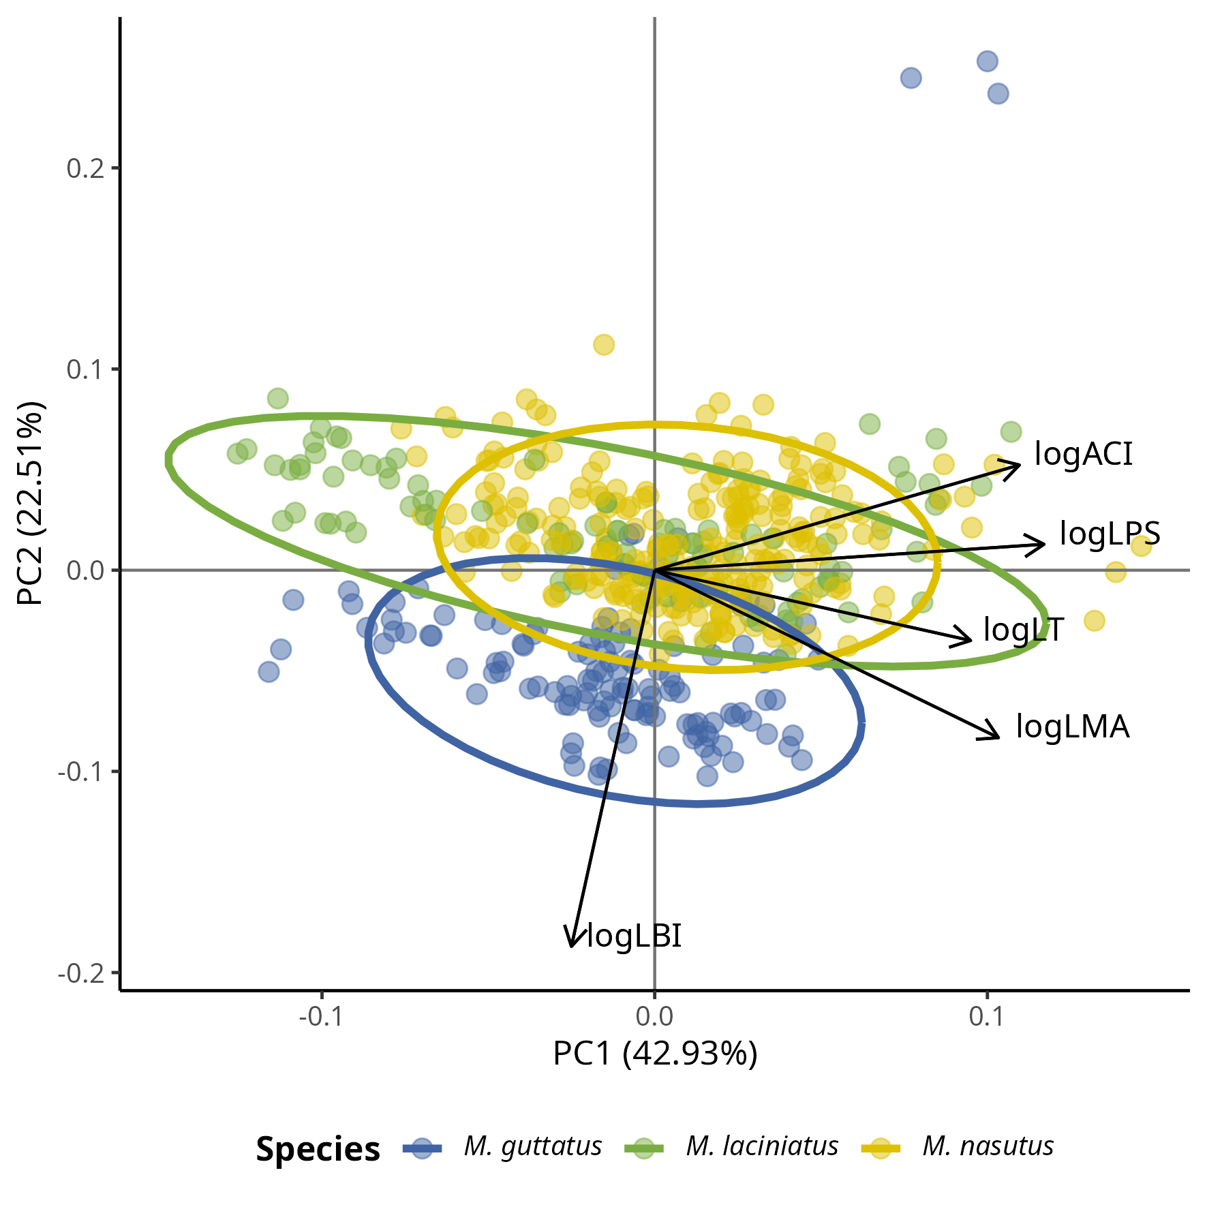

PCA of leaf traits by species.

## 12.2 Figure 2



Scatter plots of of Hill orders by host species. Blue filled points correspond to *M. laciniatus*, green filled to *M. nasutus*, and yellow to *M. guttatus*. The solid line represents the linear model fit and the shaded area represents the 95% confidence interval.

## 12.3 Figure 3



Violin plot of Hill orders by host species and elevation category. A) Blue filled violins correspond to *M. laciniatus*, green filled to *M. nasutus*, and yellow to *M. guttatus*. B) Light blue violins correspond to LOW elevation sites, light yellow to MID and maroon to HIGH elevation sites, while sques represent *M. laciniatus* , circles *M. nasutus* and triangles *M. guttatus*. Significance levels are represented by *ns* (not significant) and asterisks [*p* < 0.05 (*), *p* < 0.01 (\**\*),* *p* < 0.001 (**\*\*\*),** and *p* < 0.0001 (****)].

## 12.4 Figure 4

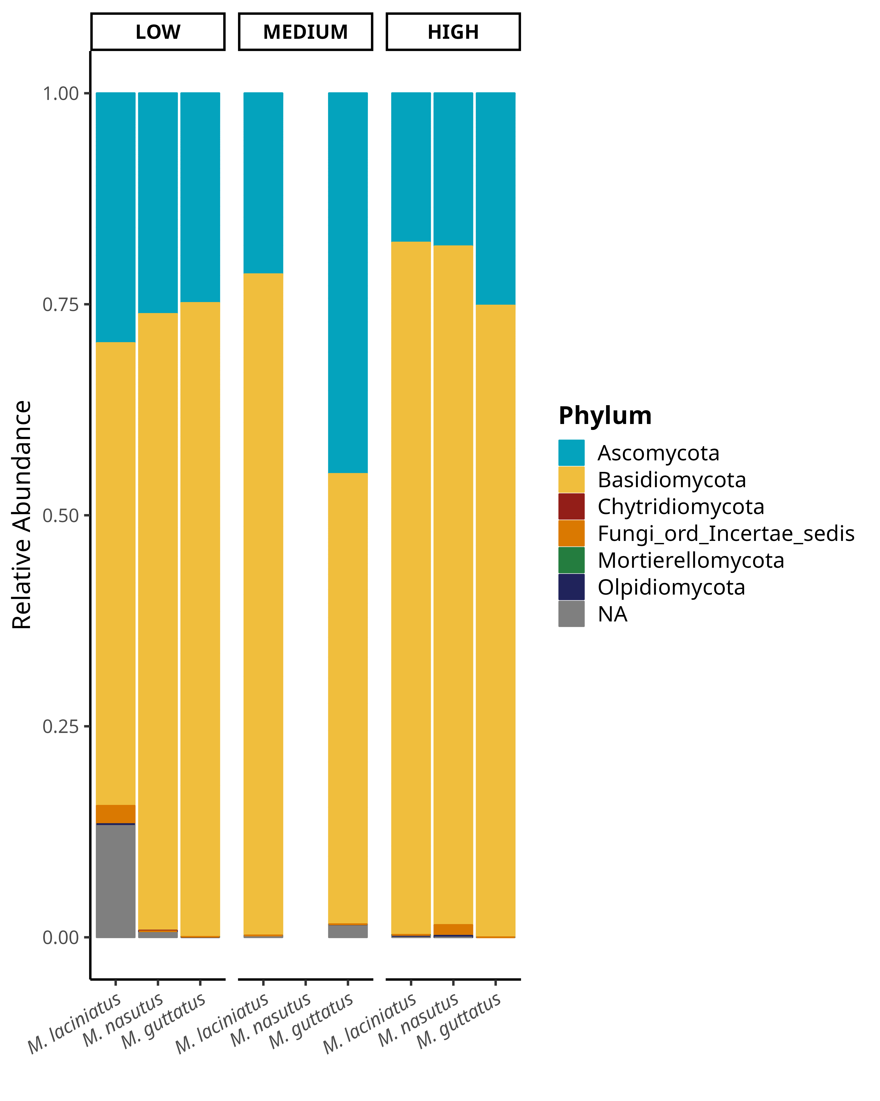

Bar plot of relative abundance of fungal phyla by species and elevation category.

## 12.5 Figure 5

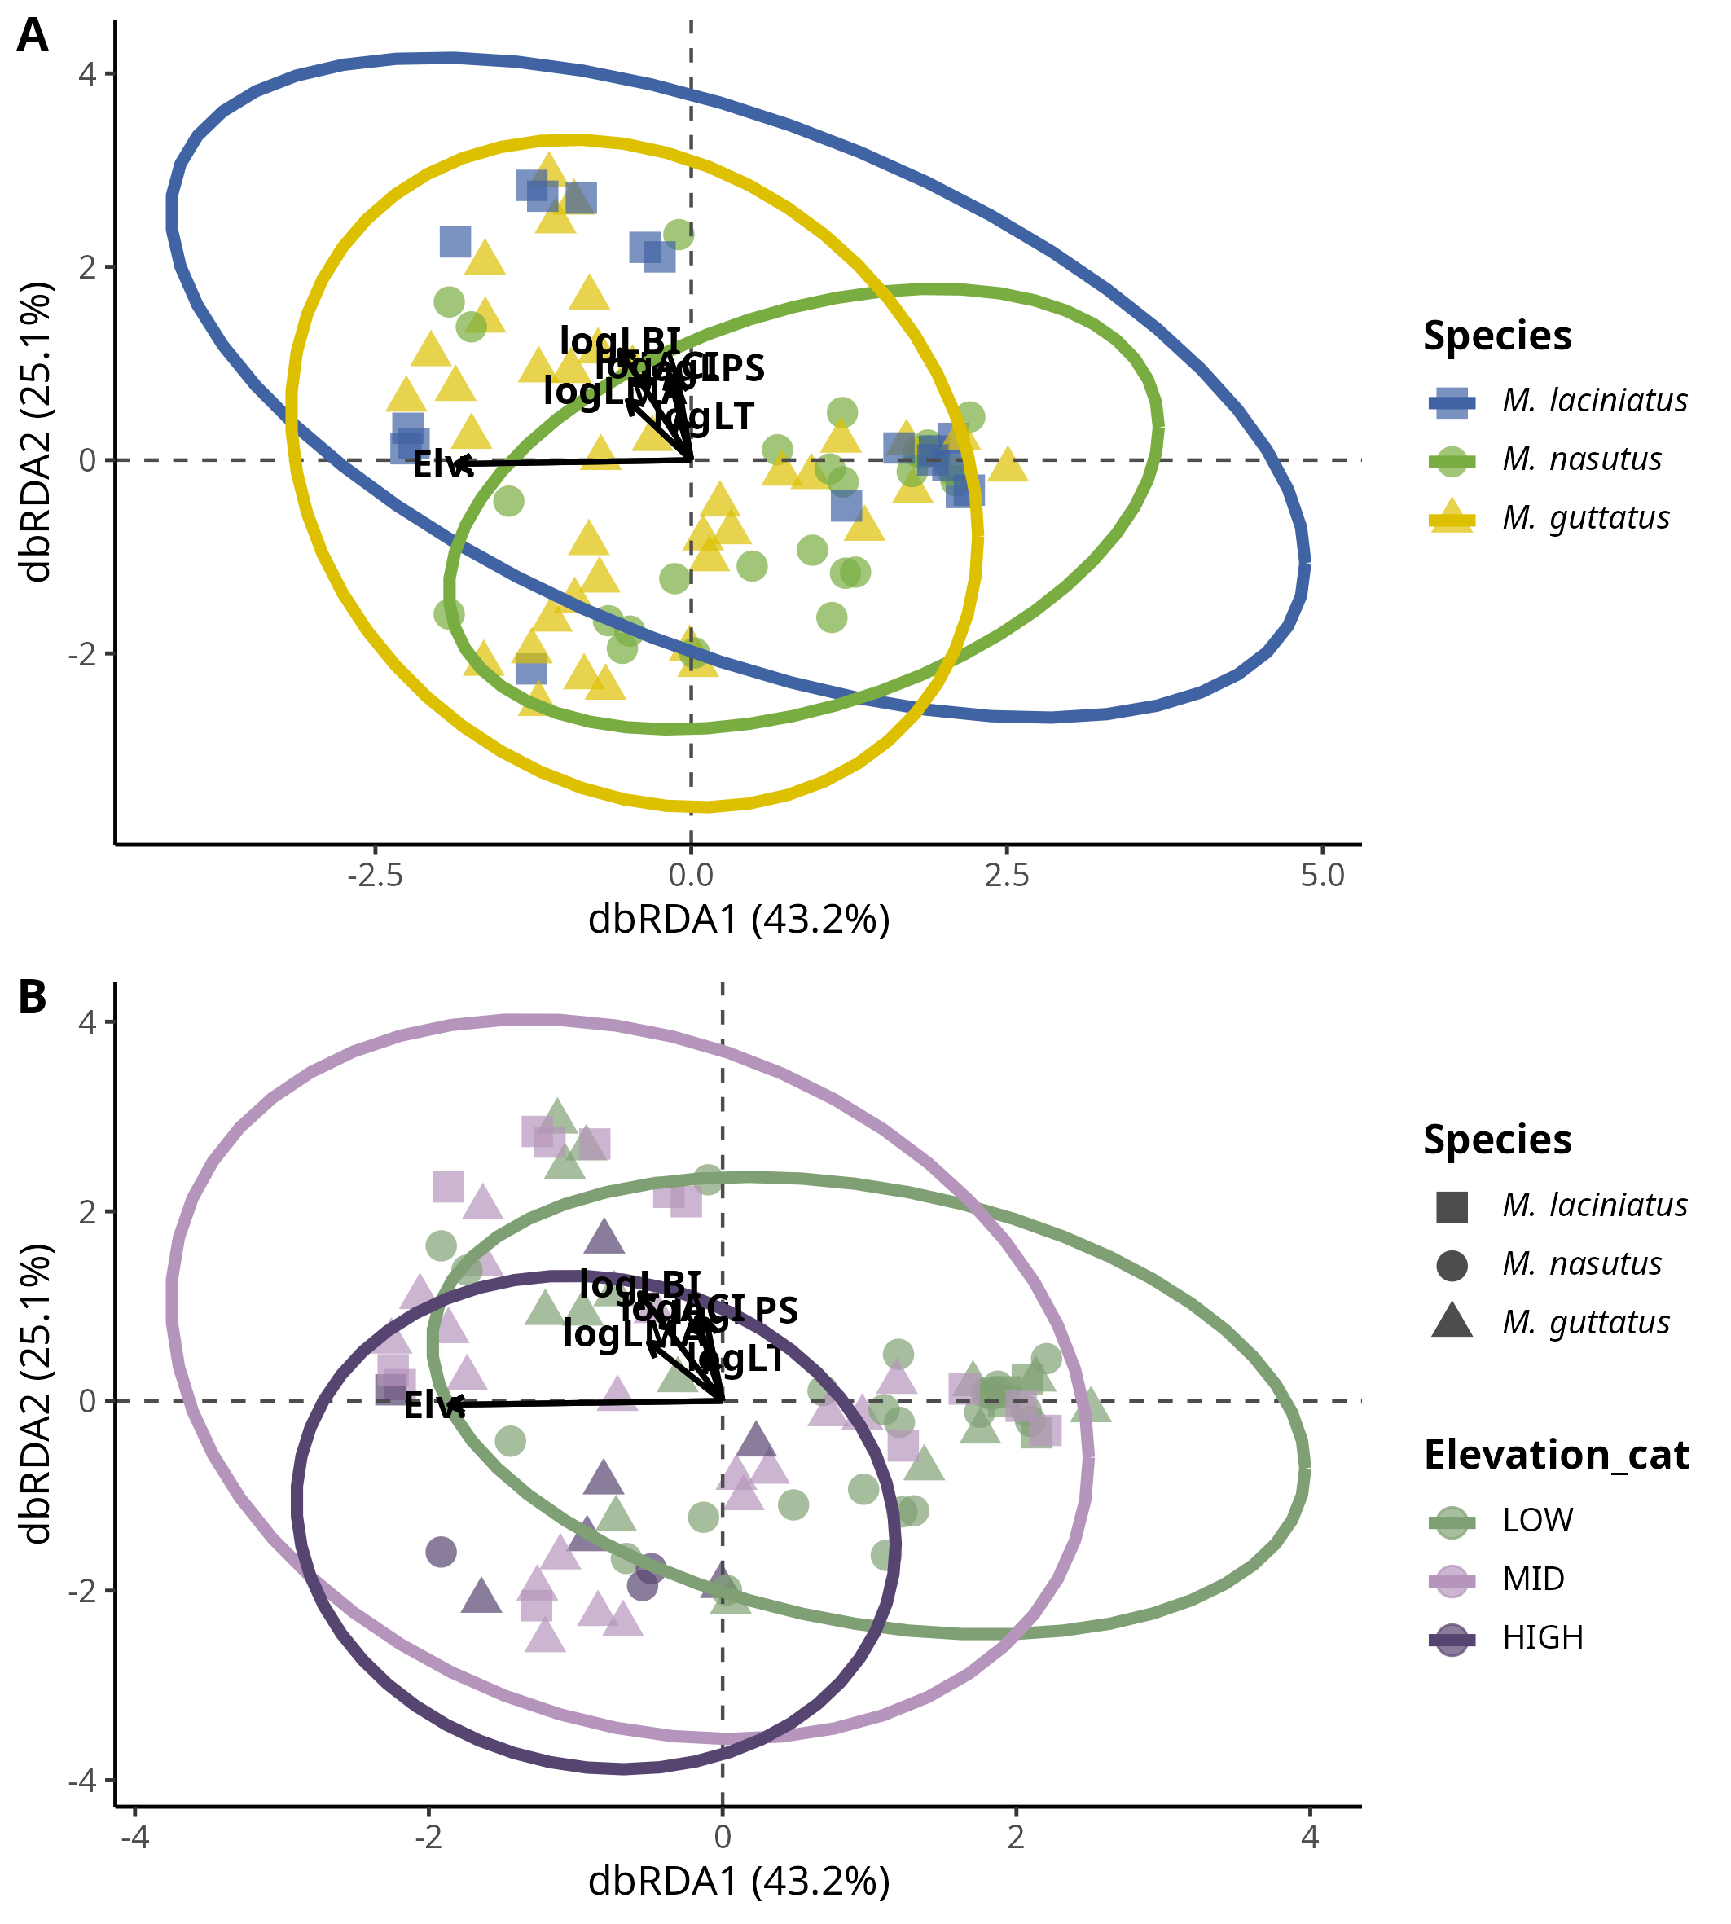

FEF community composition association with leaf functional traits, especially log(LBI) and Elevation, per host species. Distance-based Redundancy Analysis (dbRDA) plot of leaf functional traits by species. Each point represents a FEF community sample from one host species; colors represent host species

# 13. Figure 6

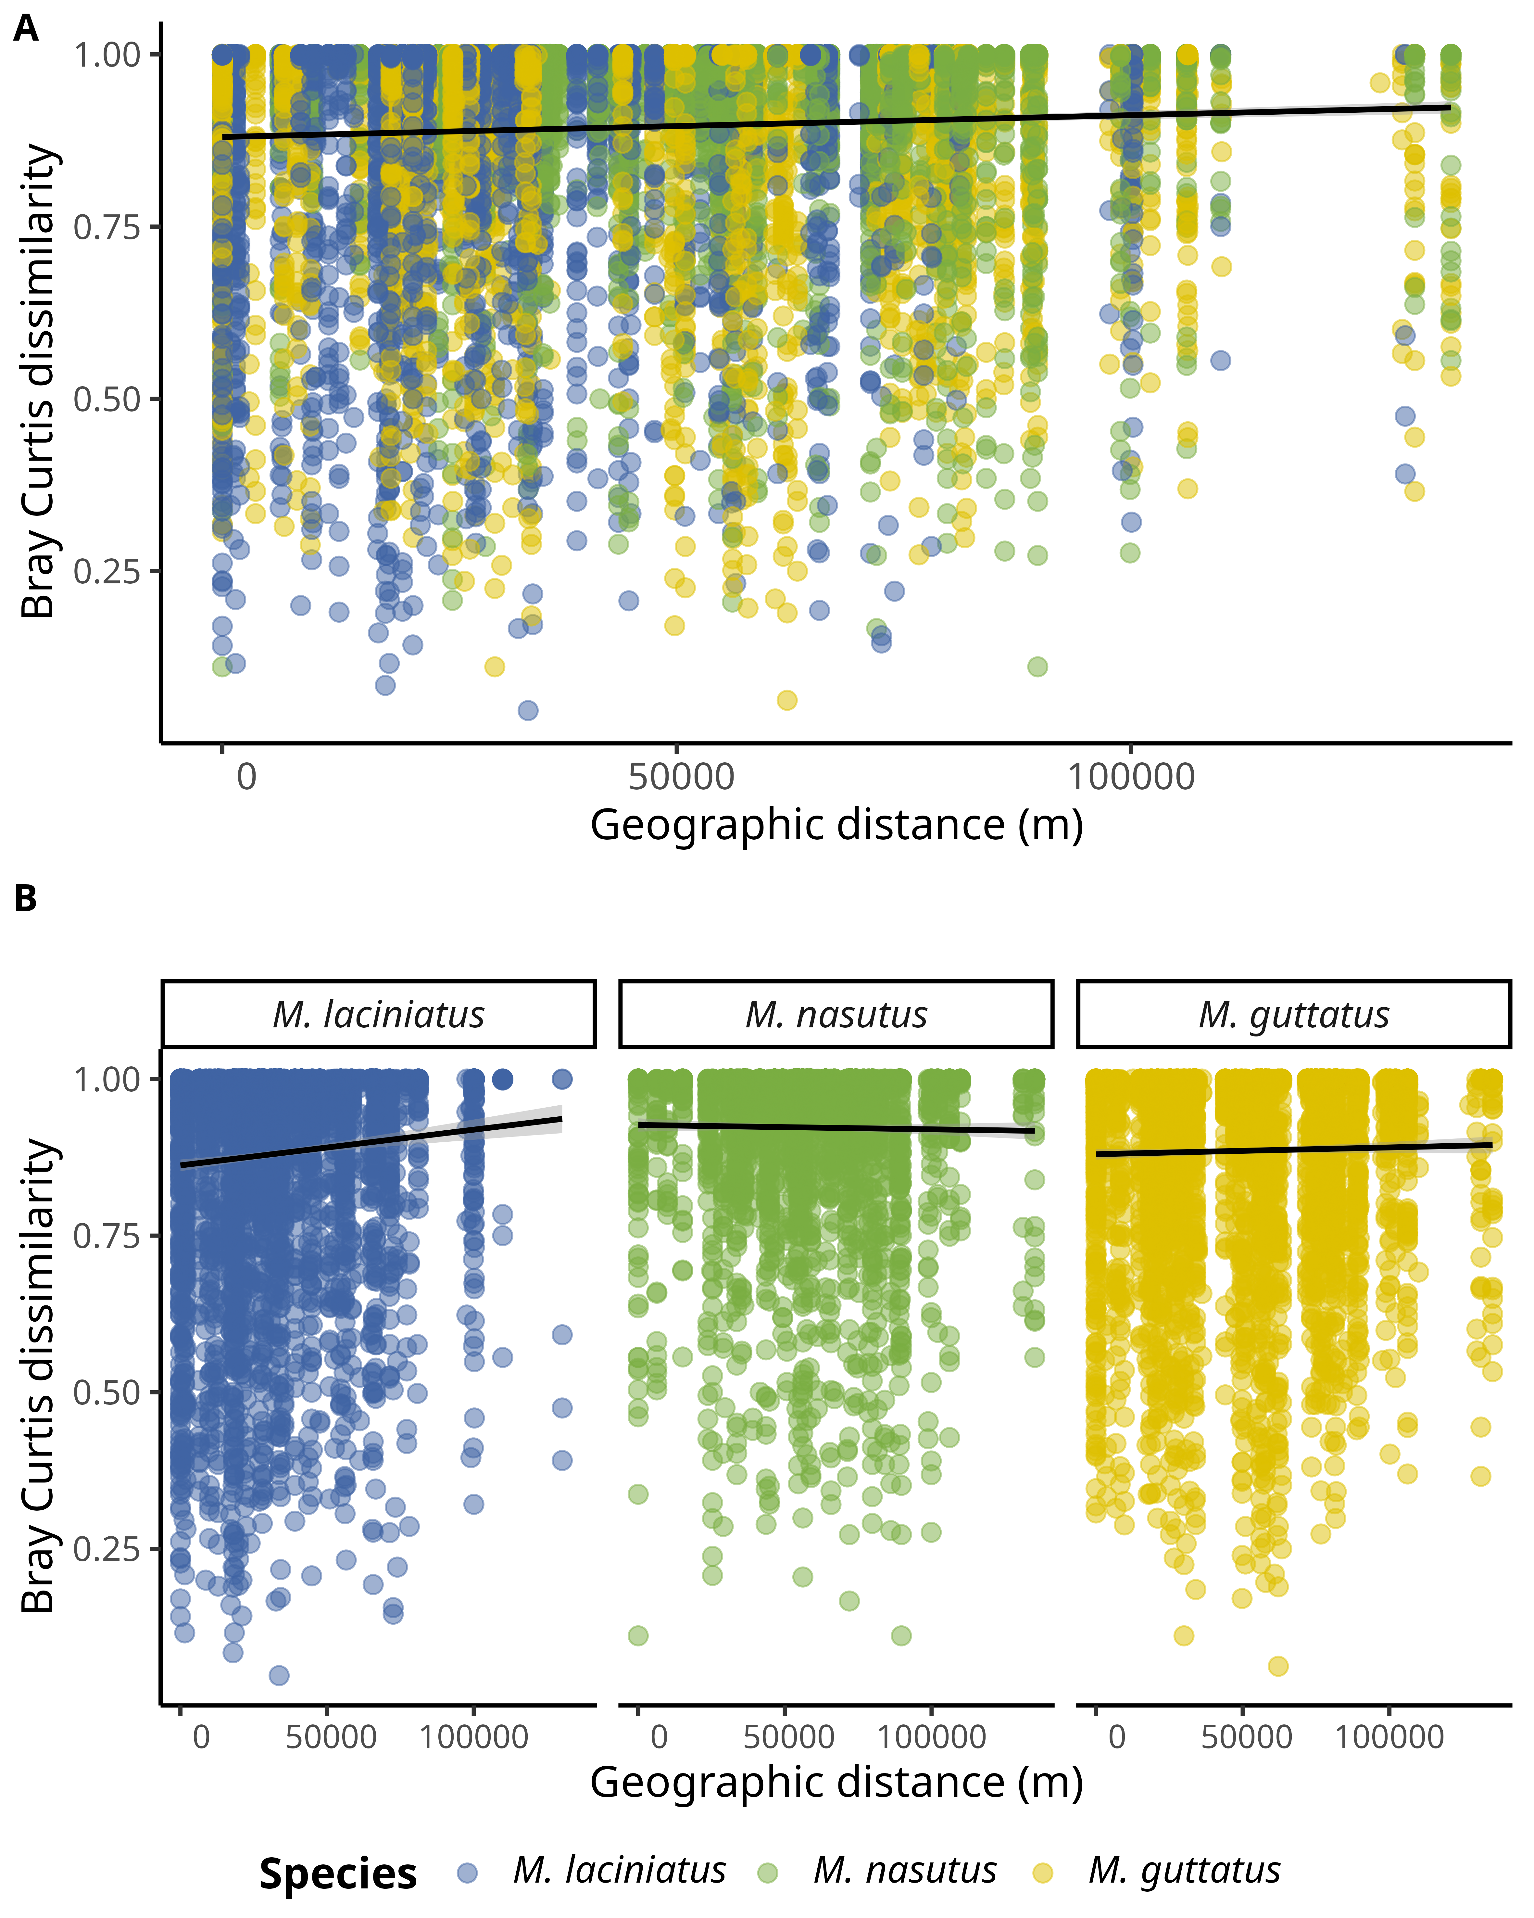

Scatter plot of Bray-Curtis dissimilarity by geographic distance.

# 14. Supplementary Material

## 14.1 Figure S1

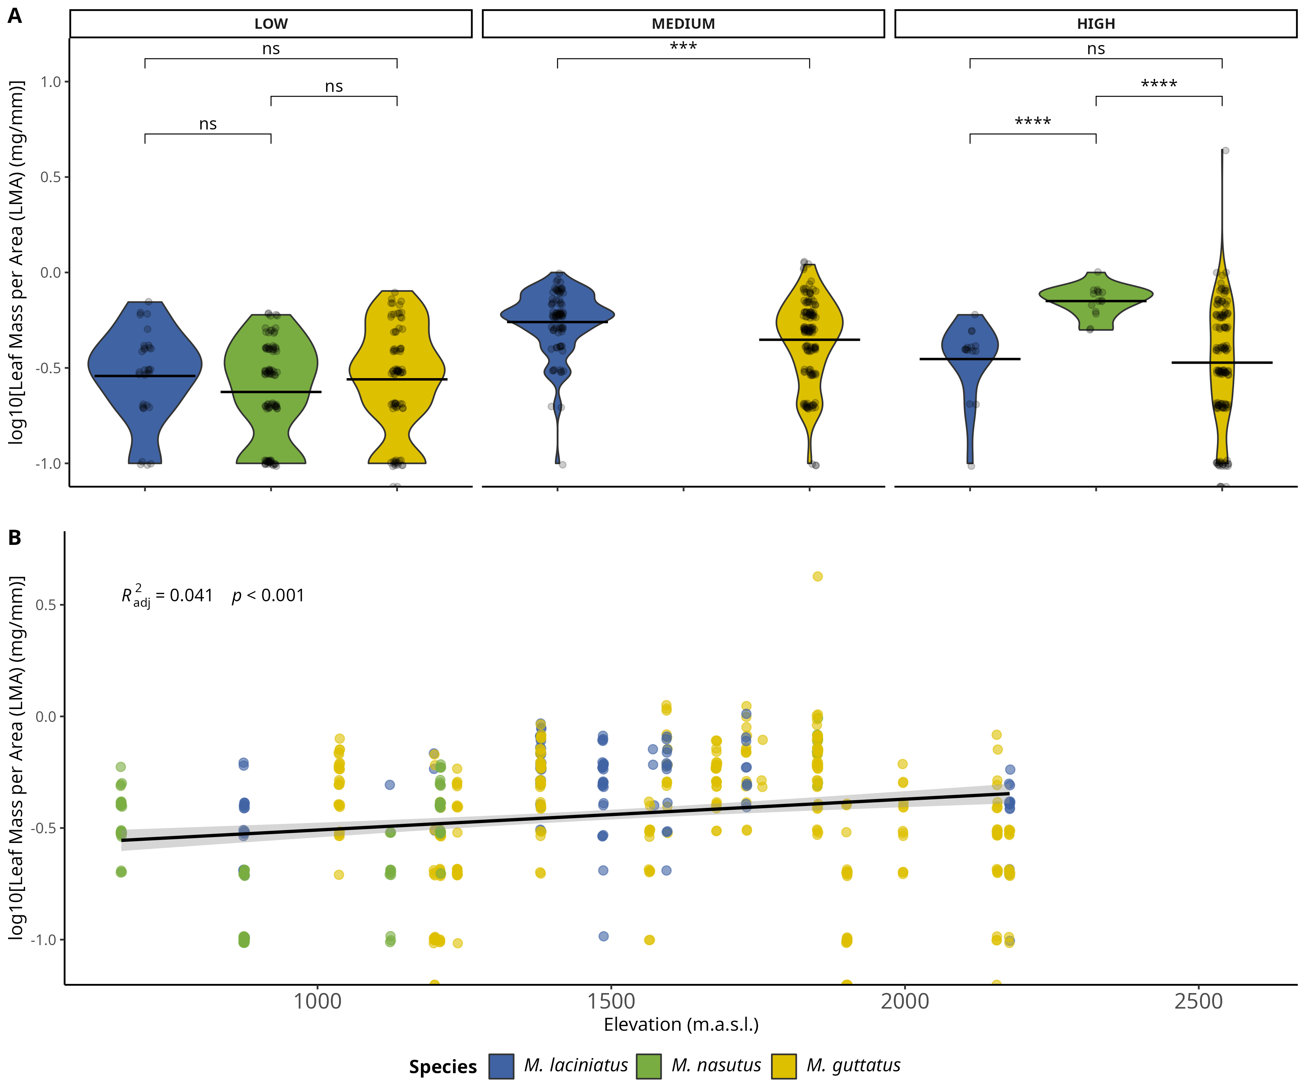

Comparison of log-transformed leaf mass per area (LMA) by species and elevation category. A) Compares logLMA means by species and elevation category: LOW (<1220 m), MID (1221 - 1828 m), HIGH (> 1829 m). The black line across violins represents the mean value. B) Change in logLMA per species as elevation increases. Significance levels are represented by *ns* (not significant) and asterisks [*p* < 0.05 (*), *p* < 0.01 (\**\*),* *p* < 0.001 (**\*\*\*),** and *p* < 0.0001 (****)].

## 14.2 Figure S2



Change in log-transformed anthocyanin condent index (ACI) by species and elevation category. A) Compares logACI means by species and elevation category: LOW (<1220 m), MID (1221 - 1828 m), HIGH (> 1829 m). The black line across violins represents the mean value. B) Change in logLPS per species as elevation increases. Significance levels are represented by *ns* (not significant) and asterisks [*p* < 0.05 (*), *p* < 0.01 (\**\*),* *p* < 0.001 (**\*\*\*),** and *p* < 0.0001 (****)].

## 14.3 Figure S3



Change in log-transformed leaf lobe index (LBI) by species and elevation category. A) Compares logLBI means by species and elevation category: LOW (<1220 m), MID (1221 - 1828 m), HIGH (> 1829 m). The black line across violins represents the mean value. B) Change in logLPS per species as elevation increases. Significance levels are represented by *ns* (not significant) and asterisks [*p* < 0.05 (*), *p* < 0.01 (\**\*),* *p* < 0.001 (**\*\*\*)**, and *p* < 0.0001 (****)].

## 14.4 Figure S4



Change in log-transformed leaf-punch strength (LPS), a measure of leaf toughness, by species and elevation category. A) Compares logLPS means by species and elevation category: LOW (<1220 m), MID (1221 - 1828 m), HIGH (> 1829 m). The black line across violins represents the mean value. B) Change in logLPS per species as elevation increases. Significance levels are represented by *ns* (not significant) and asterisks [*p* < 0.05 (*), *p* < 0.01 (\**\*),* *p* < 0.001 (**\*\*\*),** and *p* < 0.0001 (****)].

## 14.5 Figure S5



Change in log-transformed leaf thickness (LT) (𝜇m) by species and elevation category. A) Compares logLT means by species and elevation category: LOW (<1220 m), MID (1221 - 1828 m), HIGH (> 1829 m). The black line across violins represents the mean value. B) Change in logLT per species as elevation increases. Significance levels are represented by *ns* (not significant) and asterisks [*p* < 0.05 (*), *p* < 0.01 (\*\**), p* < 0.001 (\*\*\***)**, and *p* < 0.0001 (****)].